

**Digital Logic Lab Assignment # 18**

1. **To verify the operation of Asynchronous and Synchronous:**

* **2-bit Counter**
* **4-bit Counter**
* **BCD**

**Submitted By**

Gaurav Chaulagain

Year I / SEM I

017BSCIT014

**Submitted To**

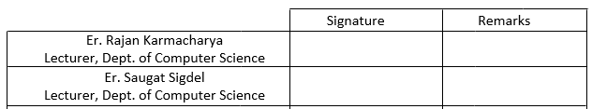

**OBJECTIVE 1.1**

**To Construct Asynchronous counter**

**THEORY:**

Flip Flops can be connected together to perform counting operations and such a group of flip flops is called a counter. It is a register that goes through a pre determined sequence of steps upon the application of input pulse. The input pulse may be clock pulse or they may originate from an external source.

In counters, the number of flip flops used and the way in which they are connected determines the number of states called the modulus. Counters are found in almost all equipments containing digital logic, for counting the number of occurrences of an event and are useful for generating timing sequences to control operations in a digital system.

Of various sequences a counter may follow, the straight binary sequence is the simplest and most straight-forward. Such counter is called binary counter.

An n-bit binary counter consists of n flip flops and can count in binary from 0 to 2n-1.

Types of counter:

1. Asynchronous Counter
2. Synchronous Counter

**Asynchronous Counter**

It refers to the events that do not have a fixed time relationship with each other and generally do not occur at the same time. FFs within the counter do not change states at exactly the same time because they do not have a common clock pulse.

**2-Bit:**

**Circuit Diagram:**

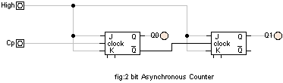

**Observation:**

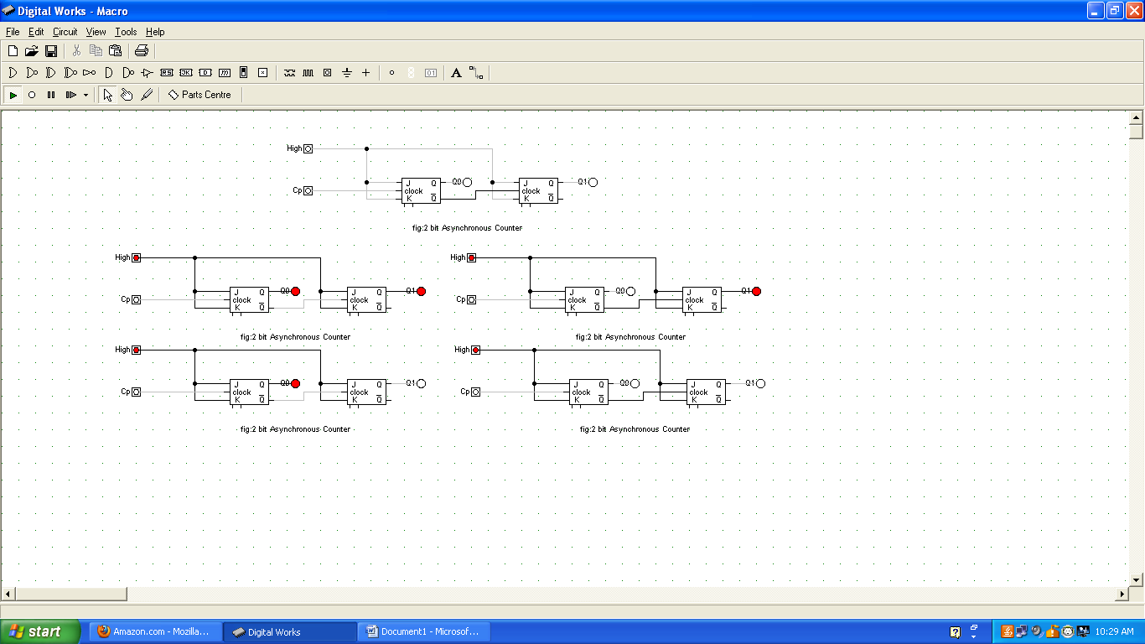

**4-Bit:**

**Circuit diagram:**

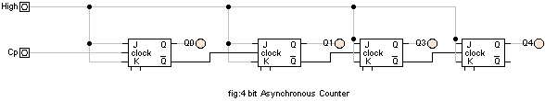

**Observation:**

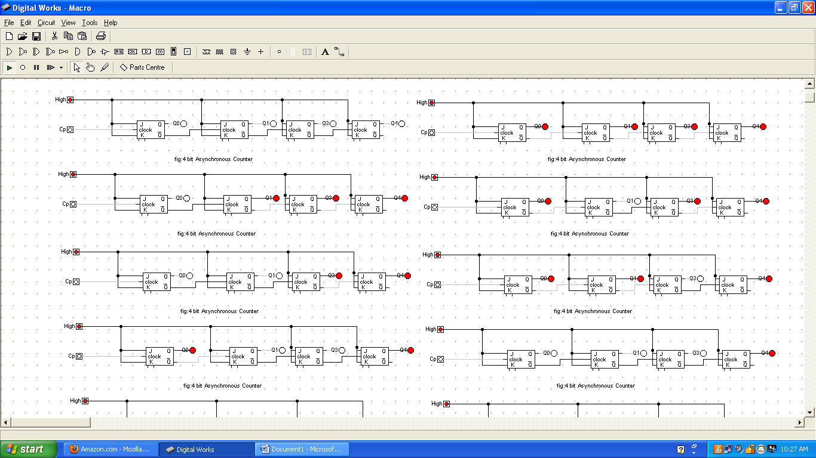

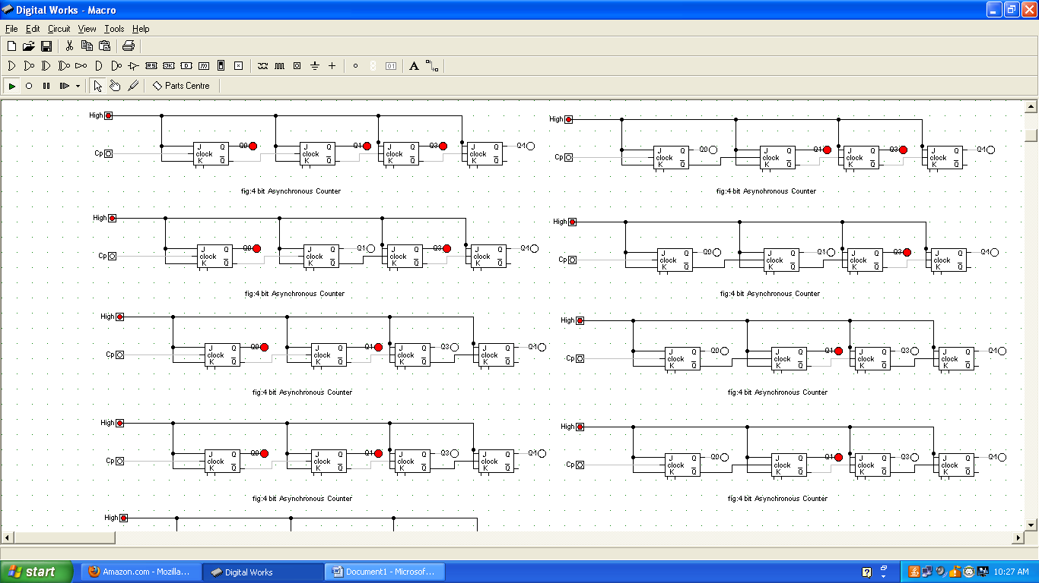

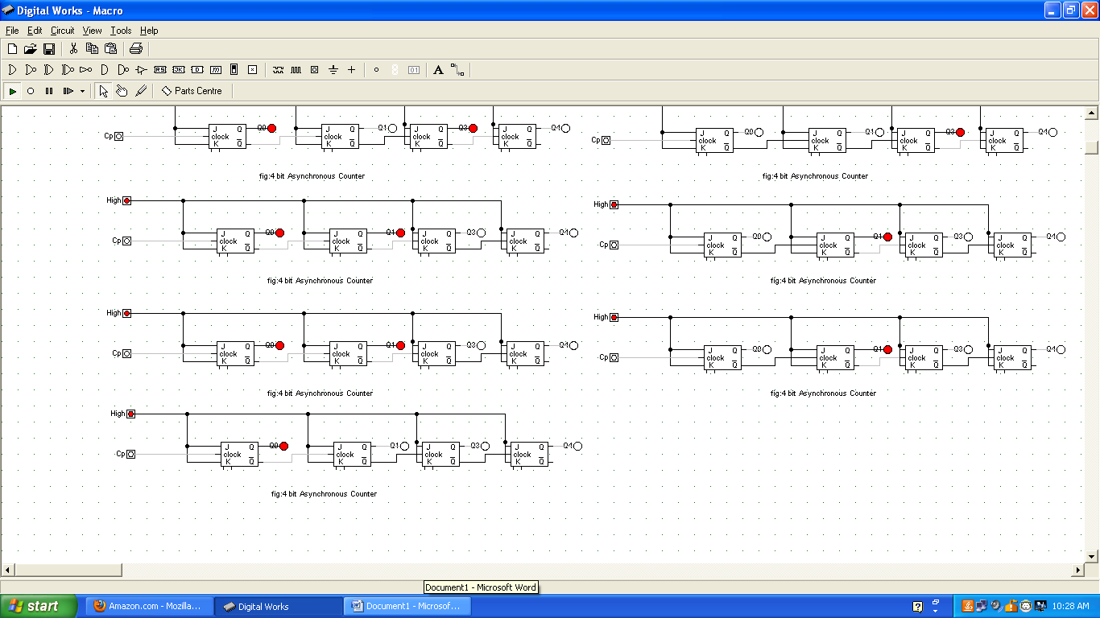

**BCD**

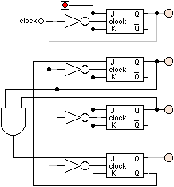

**Conclusion:**

Thus, an asynchronous counter was constructed.

**OBJECTIVE 1.2**

**To Construct Synchronous counter**

**THEORY:**

Flip Flops can be connected together to perform counting operations and such a group of flip flops is called a counter. It is a register that goes through a pre determined sequence of steps upon the application of input pulse. The input pulse may be clock pulse or they may originate from an external source.

In counters, the number of flip flops used and the way in which they are connected determines the number of states called the modulus. Counters are found in almost all equipments containing digital logic, for counting the number of occurrences of an event and are useful for generating timing sequences to control operations in a digital system.

Of various sequences a counter may follow, the straight binary sequence is the simplest and most straight-forward. Such counter is called binary counter.

An n-bit binary counter consists of n flip flops and can count in binary from 0 to 2n-1.

Types of counter:

1. Asynchronous Counter
2. Synchronous Counter

**Synchronous Counter**

They are synchronous to the events that have a fixed time relationship with each other. FFs within the counter change state at the same time because all FFs re clocked by a common CP. The common pulse triggers all the FFs simultaneously rather than one at a time in succession as in ripple counters.

**Circuit diagram**

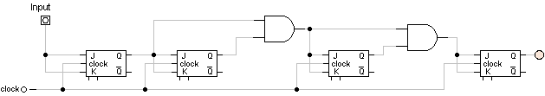

**State Sequence**

|  |  |  |  |  |
| --- | --- | --- | --- | --- |
| **Clock** | **Q3** | **Q2** | **Q1** | **Q0** |
| Initially | 0 | 0 | 0 | 0 |
| 1 | 0 | 0 | 0 | 1 |
| 2 | 0 | 0 | 1 | 0 |
| 3 | 0 | 0 | 1 | 1 |
| 4 | 0 | 1 | 0 | 0 |
| 5 | 0 | 1 | 0 | 1 |
| 6 | 0 | 1 | 1 | 0 |
| 7 | 0 | 1 | 1 | 1 |
| 8 | 1 | 0 | 0 | 0 |
| 9 | 1 | 0 | 0 | 1 |
| 10 | 1 | 0 | 1 | 0 |
| 11 | 1 | 0 | 1 | 1 |
| 12 | 1 | 1 | 0 | 0 |
| 13 | 1 | 1 | 0 | 1 |
| 14 | 1 | 1 | 1 | 0 |
| 15 | 1 | 1 | 1 | 1 |
| 16 | 0 | 0 | 0 | 0 |

**Observation**

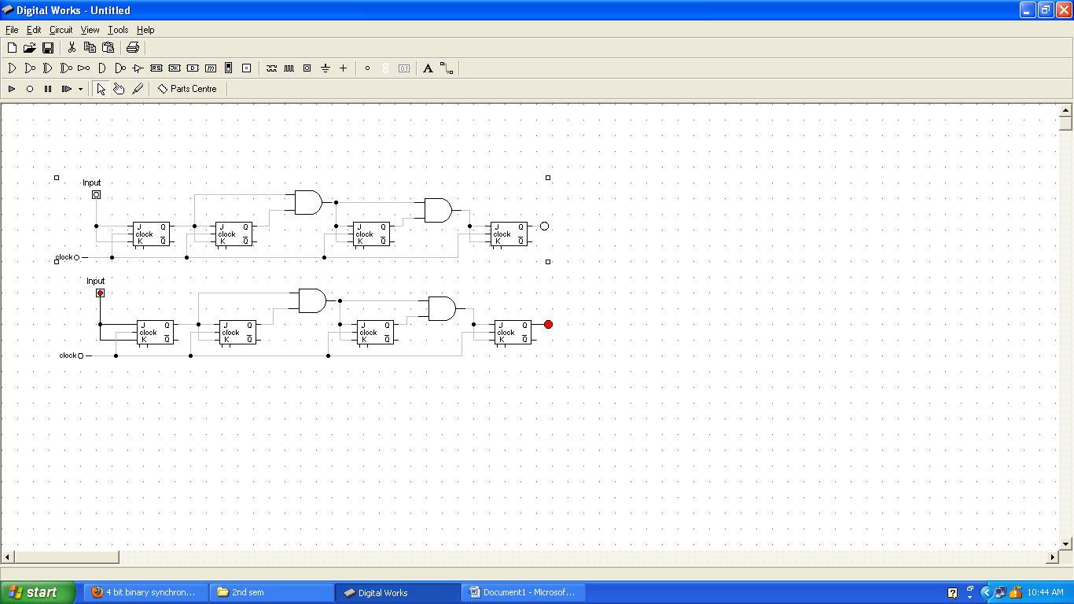



**Conclusion**

Hence the 4 bit binary synchronous counter was verified